MASTERING NEURAL NETWORKS
To master Neural Networks for Deep Learning and Generative AI, you should first build a very strong foundation before moving to CNNs, RNNs, LSTMs, Transformers, and LLMs.
I'll structure this from absolute basics → mathematical intuition → training → advanced architectures → Generative AI connection, using simple language.
🧠 Complete Neural Network Mastery
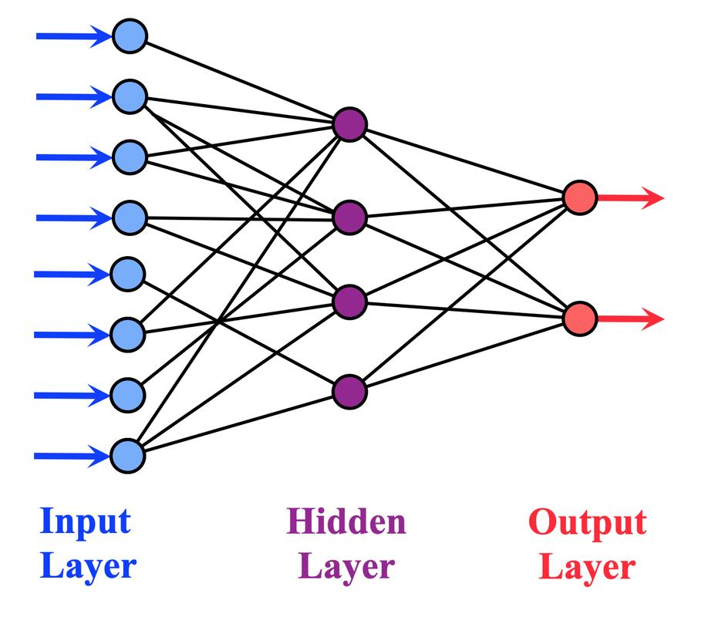
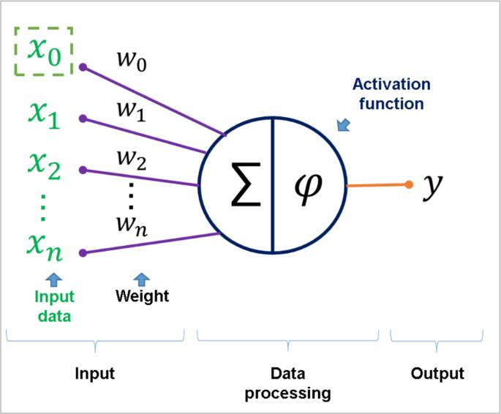
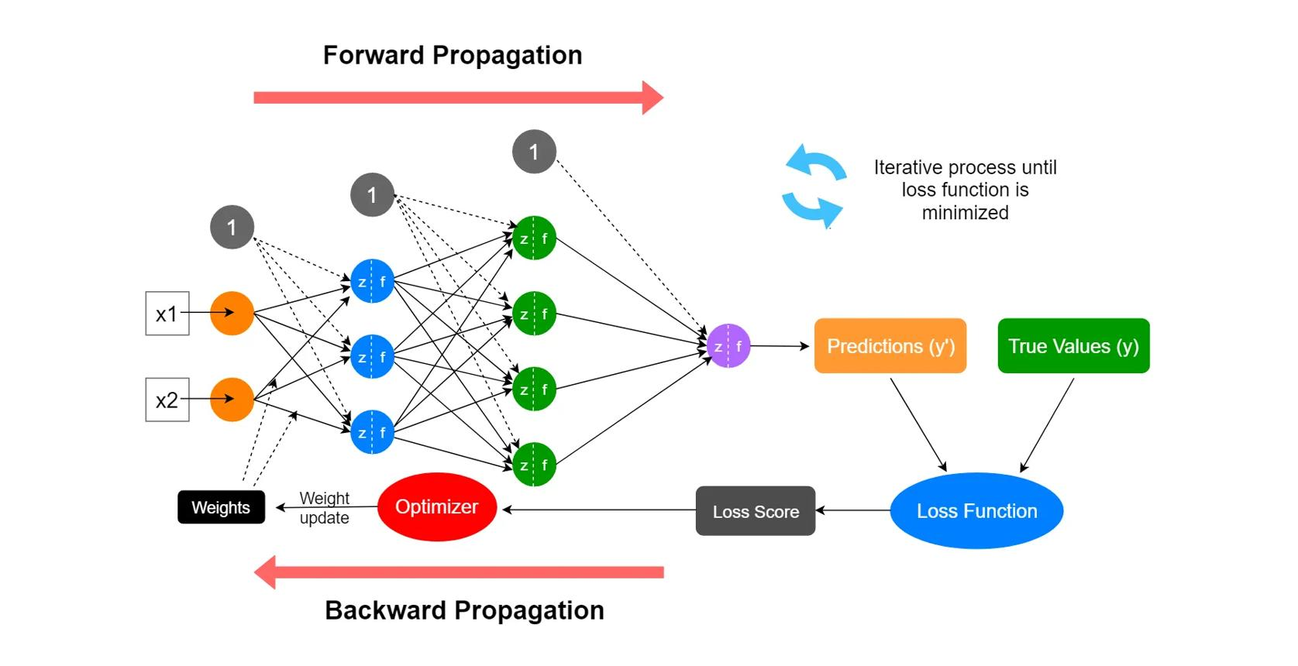
4

1. What is a Neural Network?
A Neural Network is a machine learning model that learns patterns from data.
For example, suppose we give it:
Hours studied → Exam score

1 → 35
2 → 42
3 → 50
4 → 61
5 → 70
The neural network tries to learn the relationship:
Hours studied
↓
Neural Network
↓
Predicted Score
After training, if you give:
6 hours
it might predict:
78
So, in simple words:
A neural network learns a relationship between inputs and outputs by adjusting internal parameters called weights and biases.

2. Why is it Called a Neural Network?
It is loosely inspired by biological neurons.
A biological neuron receives signals, processes them, and sends a signal.
Artificial neural networks use mathematical units called:

Artificial neurons
A simplified artificial neuron looks like:
Input 1 ──┐
Input 2 ──┤
Input 3 ──┤
Input 4 ──┘
↓
Neuron
↓
Output

3. The Basic Artificial Neuron
Suppose we have:
x₁ = 2
x₂ = 3
The neuron also has weights:
w₁ = 0.5
w₂ = 0.8
It calculates:
where:
- x = input
- w = weight
- b = bias
- z = weighted sum
Then an activation function is applied.
Inputs
↓
Multiply by weights
↓
Add everything
↓
Add bias
↓
Activation function
↓
Output
This is the fundamental operation behind neural networks.

4. What is a Weight?
A weight tells the neural network how important an input is.
Suppose we're predicting whether someone will buy a car.
Inputs:
Income
Age
Credit Score
The network might learn:
Income → important
Age → moderately important
Credit Score → very important
The importance is represented through learned weights.
For example:
Income → weight = 0.8
Age → weight = 0.2
Credit Score → weight = 1.2
These are just illustrative values.

5. What is Bias?
Bias gives the neuron additional flexibility.
The basic calculation is:
Without bias, the model has fewer ways to fit the data.
Think of bias as:
An adjustable starting point.

6. Neuron Example
Suppose:
x₁ = 2
x₂ = 4

w₁ = 0.5
w₂ = 0.2

b = 1
Then:
Then the activation function processes 2.8.

7. What is an Activation Function?
This is extremely important.
Without activation functions, a neural network would essentially behave like a linear model no matter how many linear layers you stack.
The activation function introduces non-linearity.
It allows the network to learn complex patterns.
Common activation functions:
- Sigmoid
- Tanh
- ReLU
- Leaky ReLU
- ELU
- GELU
- Softmax
- SiLU / Swish

8. Sigmoid
Formula:
Output range:
0 to 1
Example:
x = 2

sigmoid(2) ≈ 0.88
Useful when interpreting output as a probability in certain binary classification setups.
Example:
Spam probability = 0.92

9. Tanh
Tanh outputs values between:
-1 and +1
It was historically common in RNNs and LSTMs.
Example:
-1 ←──── 0 ────→ +1

10. ReLU
ReLU is one of the most important activation functions.
Formula:
So:
x = 5
→ 5

x = -5
→ 0

x = 0
→ 0
In simple terms:
Positive values pass through; negative values become zero.
ReLU became extremely popular because it is simple and helps deep networks train effectively.

11. Leaky ReLU
A problem with ReLU is that neurons can sometimes become inactive for negative inputs.
Leaky ReLU allows a small negative value through.
Conceptually:
Positive → normal
Negative → small value
This can reduce the "dead neuron" problem associated with standard ReLU.

12. GELU
GELU stands for:
Gaussian Error Linear Unit
It's widely used in Transformer architectures.
You will encounter GELU frequently when studying:
- BERT
- GPT-family architectures
- Transformer blocks

13. Softmax
Softmax converts a set of scores into probabilities that sum to 1.
Suppose the model produces:
Cat = 2.0
Dog = 1.0
Bird = 0.5
Softmax converts these into something like:
Cat = 0.63
Dog = 0.23
Bird = 0.14
The exact values depend on the calculation.
So:
Raw scores
↓
Softmax
↓
Probabilities
Softmax is commonly used for multi-class classification and also appears at the output of language models.

14. Layers in a Neural Network
A neural network usually contains:
Input Layer
Receives the data.
Hidden Layers
Learn patterns.
Output Layer
Produces the final prediction.
Example:
Input Layer
↓
Hidden Layer 1
↓
Hidden Layer 2
↓
Hidden Layer 3
↓
Output Layer

15. What is a Hidden Layer?
A hidden layer is simply a layer between the input and output.
Suppose we have:
Age
Income
Credit Score
The first hidden layer might learn basic relationships.
The next layer can combine those relationships.
The deeper layers can learn increasingly complex patterns.

16. Shallow vs Deep Neural Network
Shallow network
Input
↓
One hidden layer
↓
Output
Deep neural network
Input
↓
Hidden 1
↓
Hidden 2
↓
Hidden 3
↓
Hidden 4
↓
Output
A neural network with many hidden layers is called a:
Deep Neural Network (DNN)
That's where the term Deep Learning comes from.

17. What is Forward Propagation?
Forward propagation means:
Moving data from input → output to make a prediction.
Example:
Input
↓
Layer 1
↓
Activation
↓
Layer 2
↓
Activation
↓
Output
Suppose we're predicting house price:
Area
Bedrooms
Location
↓
Neural Network
↓
₹75 lakh
The prediction happens during forward propagation.

18. What is Loss?
The model makes a prediction.
Suppose:
Actual price = ₹80 lakh
Predicted price = ₹70 lakh
There is an error.
A loss function measures how wrong the model is.
Think:
Loss = How bad was my prediction?
Lower loss generally means the predictions are closer to the target for the chosen objective.

19. Common Loss Functions
For regression:
MSE
Mean Squared Error:
MAE
Mean Absolute Error:
For classification:
Binary Cross Entropy
Used commonly for binary classification.
Categorical Cross Entropy
Used commonly for multi-class classification.
For language models:
Cross-entropy loss / next-token prediction loss
is fundamental.

20. What is Backpropagation?
This is one of the most important concepts in Deep Learning.
After the model makes a prediction:
Input
↓
Neural Network
↓
Prediction
we calculate the loss.
Then we ask:
Which weights caused the error, and how should they change?
The network sends information backward:
Output
↑
Layer 3
↑
Layer 2
↑
Layer 1
This is called:
Backpropagation

21. What is a Gradient?
A gradient tells the model:
How the loss changes when a parameter changes.
In simpler language:
Gradient tells the model which direction and how strongly to adjust its weights to reduce the loss.
For example:
Large gradient
→ make a larger correction

Small gradient
→ make a smaller correction

22. Gradient Descent
Now we have:
Loss
+
Gradient
We need a method to update weights.
That's:
Gradient Descent
Imagine you're standing on a mountain and want to reach the lowest point.
●
/
/
●
/
●
↓
Lowest point
The model tries to move toward lower loss.
Conceptually:
Weights
↓
Prediction
↓
Loss
↓
Gradient
↓
Update weights
↓
Prediction improves
This happens repeatedly.

23. Learning Rate
The learning rate controls:
How big a step should we take when updating weights?
Large learning rate
Big steps
Can overshoot the best region.
Small learning rate
Tiny steps
Training can become very slow.
So learning rate is one of the most important hyperparameters.

24. The Complete Training Cycle
This is extremely important.
Remember:
Input
↓
Forward Propagation
↓
Prediction
↓
Calculate Loss
↓
Backpropagation
↓
Calculate Gradients
↓
Update Weights
↓
Repeat
This cycle happens many times.

25. Epoch
An epoch means the model has processed the entire training dataset once.
Suppose:
10,000 training examples
One epoch:
All 10,000 examples processed once
If:
epochs = 20
the model processes the training data 20 times, subject to batching and training setup.

26. Batch
Instead of sending the entire dataset at once, we usually divide it into smaller groups.
Suppose:
Dataset = 10,000 examples
Batch size = 100
Then approximately:
100 examples → batch 1
100 examples → batch 2
...
There are:
batches per epoch.

27. Batch Size
Batch size determines how many examples are processed together before a weight update.
Common examples:
16
32
64
128
256
Smaller batches:
- Require less memory
- Can produce noisier gradient estimates
Larger batches:
- Can use hardware efficiently
- Require more memory
- Can have different optimization behavior

28. Optimizer
An optimizer decides how the model updates its weights using gradients.
Common optimizers:
SGD
Stochastic Gradient Descent.
Momentum
Adds a notion of previous update direction.
RMSProp
Adapts updates based on recent gradient magnitudes.
Adam
Combines ideas related to momentum and adaptive learning rates.
Adam is extremely common in deep learning.
You should also know:
- AdamW
- Adagrad
- Adadelta

29. Parameters vs Hyperparameters
Very important distinction.
Parameters
Learned by the model.
Examples:
Weights
Biases
Hyperparameters
Chosen by us before/during training.
Examples:
Learning rate
Batch size
Number of layers
Number of neurons
Epochs
Dropout rate
Remember:
Parameters are learned; hyperparameters are configured.

30. Overfitting
Suppose the model memorizes the training data.
Training performance:
99%
But test performance:
65%
This is likely:
Overfitting
The model learned the training examples too specifically instead of learning patterns that generalize.

31. Underfitting
Suppose:
Training accuracy = 60%
Test accuracy = 58%
The model isn't learning the underlying pattern well enough.
This is:
Underfitting

32. How to Reduce Overfitting
Common techniques:
1. Dropout
Randomly turns off some neurons during training.
Neuron
Neuron
X
Neuron
X
Neuron
This forces the network to avoid depending too heavily on specific neurons.
2. Regularization
Examples:
- L1
- L2 / weight decay
3. More data
4. Data augmentation
Especially important for images.
5. Early stopping
Stop training when validation performance stops improving.

33. Dropout
Suppose:
Before:

● ● ● ● ●
During training, some neurons are randomly ignored:
● X ● X ●
The exact dropout pattern changes across training steps.
Important:
Dropout is generally used during training, not standard inference.

34. Batch Normalization
Batch normalization normalizes intermediate activations using statistics from the mini-batch during training.
It can:
- Stabilize training
- Sometimes allow larger learning rates
- Help optimization
It is especially common in CNN-based architectures.

35. Layer Normalization
Layer normalization normalizes across features within an individual example.
It is extremely important in:
Transformers
So when studying Transformers, you will repeatedly encounter:
Attention
↓
LayerNorm

36. Vanishing Gradient
You just learned this.
During backpropagation, gradients can become extremely small.
Output
↓
0.1
↓
0.01
↓
0.001
↓
0.00001
Earlier layers receive almost no learning signal.
This is:
Vanishing Gradient Problem
It was a major challenge for deep networks and especially traditional RNNs.

37. Exploding Gradient
The opposite problem can happen.
Gradients become extremely large:
0.1
↓
1
↓
10
↓
100
↓
1000
Weights can become unstable.
This is:
Exploding Gradient Problem
Gradient clipping is one technique commonly used to control very large gradients, particularly in recurrent networks.

38. Why ReLU Helped Deep Networks
Sigmoid and tanh can saturate.
For very large positive or negative values, their derivatives can become small.
ReLU has a simpler derivative for positive values:
x > 0 → derivative = 1
x < 0 → derivative = 0
This helped make deep networks easier to optimize, although ReLU has its own issues such as dead neurons.

39. Dead ReLU
Suppose a neuron repeatedly receives negative inputs.
ReLU gives:
negative → 0
The neuron may stop contributing useful gradients.
This can create a:
Dead neuron
Leaky ReLU and other activations can help mitigate this issue.

40. Universal Approximation
A sufficiently large neural network can approximate a broad class of functions under appropriate conditions.
This is related to the:
Universal Approximation Theorem
But don't misunderstand it.
It does not mean:
"Any neural network can automatically solve any problem."
It means that certain neural network architectures have very strong function-approximation capabilities given sufficient capacity and suitable conditions.

PART 43 — DIFFERENT TYPES OF NEURAL NETWORKS
This is where Deep Learning becomes much bigger.
41. Feedforward Neural Network
Basic architecture:
Input
↓
Hidden Layers
↓
Output
Information flows forward.
No loops.

42. Perceptron
The perceptron is one of the earliest and simplest neural models.
Conceptually:
Inputs
↓
Weighted Sum
↓
Activation
↓
Output
It is mainly associated with binary classification and is historically important.
It also gives you the foundation for understanding modern neural networks.

43. MLP
MLP stands for:
Multi-Layer Perceptron
Usually:
Input
↓
Dense Layer
↓
Activation
↓
Dense Layer
↓
Activation
↓
Output
MLPs are fundamental building blocks of many neural architectures.

44. CNN
CNN stands for:
Convolutional Neural Network
Primarily associated with image and spatial data.
Typical flow:
Image
↓
Convolution
↓
Activation
↓
Pooling
↓
Convolution
↓
...
↓
Classification
CNNs learn spatial patterns such as:
Edges
↓
Shapes
↓
Objects

45. RNN
RNN stands for:
Recurrent Neural Network
Designed for sequential data.
Word 1
↓
Word 2
↓
Word 3
↓
Word 4
It maintains a hidden state.

46. LSTM
LSTM:
Long Short-Term Memory
Improves the ability to retain information over longer sequences using gates and a cell state.

47. GRU
GRU:
Gated Recurrent Unit
A simpler gated recurrent architecture related to LSTM.

48. Autoencoder
An autoencoder learns to represent data in a compressed latent representation and then reconstruct it.
Input
↓
Encoder
↓
Latent Representation
↓
Decoder
↓
Reconstructed Input
Applications can include:
- Dimensionality reduction
- Representation learning
- Anomaly detection
- Denoising

49. Variational Autoencoder
VAE stands for:
Variational Autoencoder
It learns a probabilistic latent space.
Architecture:
Input
↓
Encoder
↓
Latent Distribution
↓
Sample
↓
Decoder
↓
Generated/Reconstructed Data
VAEs are important in Generative AI because they can generate new samples.

50. GAN
GAN stands for:
Generative Adversarial Network
It contains two networks:
Generator
Creates fake data.
Discriminator
Attempts to distinguish real from generated data.
Generator
↓
Fake Data
↓
Discriminator
↑
Real Data
The two networks compete during training.
GANs have been used extensively for image generation and synthetic data generation.

51. Transformer
Transformer is the most important architecture for modern language-based Generative AI.
It uses:
Attention
instead of recurrence as its core mechanism.
Basic idea:
Tokens
↓
Embeddings
↓
Self-Attention
↓
Feed Forward
↓
Repeat
↓
Output
Transformers are the foundation of many modern LLMs.

PART 44 — NEURAL NETWORKS AND GENERATIVE AI
Now let's connect everything.
Generative AI means:
AI systems that can generate new content.
Examples:
Text
Images
Audio
Video
Code
Neural networks are the underlying learning machinery.

52. Neural Network → LLM Connection
The progression is:
Artificial Neuron
↓
Neural Network
↓
Deep Neural Network
↓
Specialized Architectures
↓
Transformer
↓
Large Language Model
↓
Generative AI

53. How an LLM Uses Neural Networks
Suppose you type:
"Explain machine learning."
The text is converted into tokens.
Text
↓
Tokenizer
↓
Token IDs
↓
Embeddings
↓
Transformer
↓
Neural Network Layers
↓
Output logits
↓
Probabilities
↓
Next token
The model repeatedly predicts the next token.

54. What is an LLM Actually Learning?
An LLM isn't simply storing a giant dictionary.
During training, its parameters learn statistical patterns and representations from enormous amounts of data.
It learns relationships involving:
Words
Concepts
Syntax
Semantics
Patterns
Code structures
Facts present in training data
The exact internal representations are distributed across many parameters and layers.

55. Parameters in Large Models
A neural network can have:
1 million parameters
10 million
100 million
1 billion
10 billion
100+ billion
A parameter is generally a learned numerical value, such as a weight.
Modern LLMs can contain billions of parameters.

56. Training a Neural Network
The complete process looks like:
DATA
↓
Preprocessing
↓
Batches
↓
Forward Pass
↓
Prediction
↓
Loss Function
↓
Backpropagation
↓
Gradients
↓
Optimizer
↓
Update Weights
↓
Next Batch
↓
Next Epoch
↓
Trained Model
This cycle may happen millions or billions of times for large models.

57. Training vs Inference
Very important distinction.
Training
The model learns.
Input
↓
Prediction
↓
Loss
↓
Backpropagation
↓
Weight update
Inference
The trained model makes predictions.
Input
↓
Model
↓
Prediction
Usually, we don't update the model's weights during ordinary inference.

58. Training Data vs Validation vs Test
Usually:
Training set
Used to learn parameters.
Validation set
Used during model development to make decisions such as hyperparameter selection.
Test set
Used for final evaluation.
Simple picture:
Dataset
↓
┌───────┬──────────┬───────┐
│ Train │Validation│ Test │
└───────┴──────────┴───────┘

59. Data Preprocessing for Neural Networks
Depending on the data, preprocessing may include:
Numerical data
- Missing-value handling
- Scaling
- Outlier treatment
Categorical data
- One-hot encoding
- Embeddings
Text
- Tokenization
- Vocabulary/token IDs
- Embeddings
Images
- Resizing
- Normalization
- Augmentation

60. Why Scaling Matters
Suppose:
Age = 25
Salary = 1,000,000
The scales are very different.
Scaling can make optimization easier.
Common methods:
Standardization
Min-Max Scaling
The right preprocessing depends on the model and problem.

PART 45 — IMPORTANT NEURAL NETWORK TERMS
You should be comfortable with these:
Term | Simple meaning
Neuron | Mathematical processing unit
Weight | Learned importance
Bias | Learned offset
Activation | Adds non-linearity
Layer | Group of neurons/operations
Forward propagation | Input → prediction
Loss | Measures prediction error
Backpropagation | Calculates how parameters contributed to loss
Gradient | Direction/rate of loss change
Optimizer | Updates parameters using gradients
Learning rate | Size of update steps
Epoch | One pass through training data
Batch | Group of training examples
Parameter | Learned value
Hyperparameter | Configured value
Overfitting | Learns training data too specifically
Underfitting | Doesn't learn enough
Regularization | Techniques to improve generalization

PART 46 — MOST IMPORTANT EQUATIONS
You don't need to memorize every equation immediately, but understand these.
Neuron
Activation
Mean Squared Error
Gradient descent
Conceptually:
where:
- w = weight
- L = loss
- η = learning rate

PART 47 — THE MOST IMPORTANT CONCEPT: LEARNING
A neural network doesn't learn by magically "understanding" the data.
It repeatedly does:
1. Make prediction
↓
2. Calculate error
↓
3. Find gradients
↓
4. Adjust weights
↓
5. Make another prediction
↓
6. Repeat
After enough iterations, the parameters can become good at representing patterns in the training objective.

PART 48 — HOW NEURAL NETWORKS LEARN FEATURES
This is particularly important for deep learning.
Consider an image of a dog.
Early layers may learn relatively simple visual patterns:
Edges
↓
Textures
↓
Shapes
↓
Parts
↓
Object-level patterns
In CNNs, this hierarchy is particularly intuitive.
In Transformers and other architectures, learned representations work differently, but the general idea that layers transform representations into increasingly useful features remains important.

PART 49 — NEURAL NETWORK vs MACHINE LEARNING
Traditional machine learning often relies more heavily on manually designed features.
For example:
Raw data
↓
Feature Engineering
↓
Machine Learning Model
↓
Prediction
Deep learning often learns useful representations automatically:
Raw data
↓
Neural Network
↓
Learned representations
↓
Prediction
This is one reason deep learning is powerful for:
- Images
- Text
- Speech
- Video

PART 50 — NEURAL NETWORK vs DEEP LEARNING
A simple distinction:
Neural Network = the family of models.
Deep Learning = using neural networks with multiple layers to learn complex representations.
You can think:
Neural Network
↓
Multiple hidden layers
↓
Deep Neural Network
↓
Deep Learning

PART 51 — NEURAL NETWORK vs RNN vs LSTM vs TRANSFORMER
This connects directly to your Transformer study.
Model | Main idea
Perceptron | Basic neuron
MLP | Fully connected neural network
CNN | Learns spatial patterns
RNN | Processes sequences recurrently
LSTM | RNN with improved memory/gates
GRU | Simpler gated RNN
Transformer | Uses attention to model relationships
A useful evolution is:
Perceptron
↓
MLP
↓
Deep Neural Networks
↓
CNN / RNN
↓
LSTM / GRU
↓
Attention
↓
Transformer
↓
LLMs
↓
Generative AI

🎯 What You Should Master for Interviews
If an interviewer asks:
"What is a neural network?"
Say:
A neural network is a machine learning model made of interconnected computational units arranged in layers. It learns patterns by transforming inputs through weighted connections and activation functions, measuring prediction error with a loss function, and updating its weights using backpropagation and an optimizer.
If they ask:
"How does a neural network learn?"
Remember:
Forward pass
↓
Prediction
↓
Loss
↓
Backpropagation
↓
Gradient
↓
Optimizer
↓
Weight update
↓
Repeat
If they ask:
"What is the role of an activation function?"
Say:
It introduces non-linearity, allowing neural networks to learn complex relationships that a stack of purely linear transformations could not represent.
If they ask:
"What is backpropagation?"
Say:
Backpropagation calculates how the loss changes with respect to the model's parameters by propagating error information backward through the network.
If they ask:
"What is a gradient?"
Say:
A gradient tells us how the loss changes when a parameter changes, providing the direction and magnitude information used to update the model's parameters.
If they ask:
"What is an optimizer?"
Say:
An optimizer uses gradients to update the model's parameters so that the loss generally decreases during training.

🧠 Your Neural Network Mental Map
You should be able to visualize the entire subject like this:
NEURAL NETWORK
│
┌───────────────┴────────────────┐
↓ ↓
COMPONENTS TRAINING
│ │
┌─────┼──────┐ ┌──────┼───────┐
↓ ↓ ↓ ↓ ↓ ↓
Weights Bias Activation Forward Loss Backprop
│ │ │
└──────────────┐ └──────┬──────┘
↓ ↓
Hidden Layers Gradients
│ ↓
↓ Optimizer
Representations ↓
│ Weight Updates
↓
Prediction
│
┌────────┼─────────┐
↓ ↓ ↓
CNN RNN Transformer
│ │ │
│ LSTM │
│ │ │
└────────┴─────────┘
↓
Deep Learning
↓
Generative AI
↓
LLMs
⭐ The most important 15 concepts to master first
Don't try to memorize everything at once. Master these in this order:
- Neuron
- Weights
- Bias
- Activation functions
- Layers
- Forward propagation
- Loss functions
- Gradient
- Backpropagation
- Gradient descent
- Optimizers
- Learning rate
- Epoch & batch
- Overfitting & regularization
- Vanishing/exploding gradients
Then move to:
Perceptron
↓
MLP
↓
CNN
↓
RNN
↓
LSTM
↓
Attention
↓
Transformer
↓
GPT/BERT
↓
LLMs
↓
Generative AI
Once these fundamentals are clear, Transformers become much easier, because a Transformer is still a neural network—it simply uses specialized components such as self-attention, multi-head attention, feed-forward networks, residual connections, and normalization to process sequences very effectively.

